# Experiment 4: Distance Vector Routing

**Aim:** To generate routing tables for a network of routers using Distance Vector Routing

**Objective:** After carrying out this experiment, students will be able to:

* Generate routing tables for a given network using Distance Vector Routing
* Analyze the reasons why Distance Vector Routing is adaptive in nature

**Problem statement:** You are required to write a program that can generate routing tables for a network of routers. Take the number of nodes and the adjacency matrix as input from user. Your program should use this adjacency matrix and create routing tables for all the nodes in the network. The routing table should consist of one entry per destination. This entry should contain the total cost and the outgoing line to reach that destination.

**Analysis:** While analyzing your program, you are required to address the following points:

* Why is Distance Vector Routing classified as an adaptive routing algorithm?
* Limitations of Distance Vector Routing

**MARKS DISTRIBUTION**

|  |  |  |
| --- | --- | --- |
| **Component** | **Maximum Marks** | **Marks Obtained** |
| Preparation of Document | 7 |  |
| Results | 7 |  |
| Viva | 6 |  |
| **Total** | **20** |  |

Submitted by: PRACHI PODDAR

Register No: 17ETCS002122

1. Algorithm/Flowchart

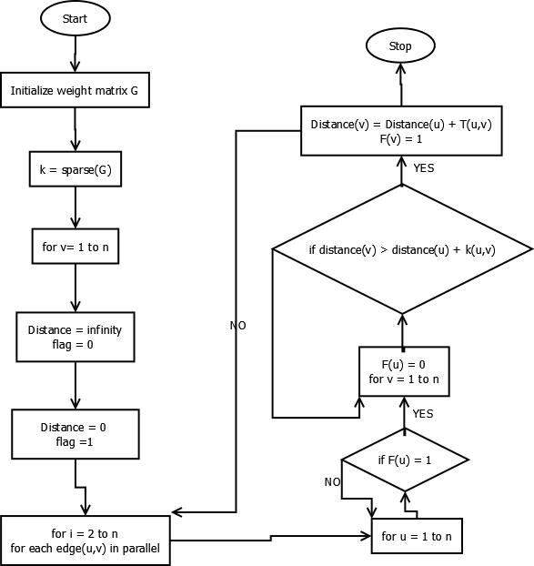

1. Program

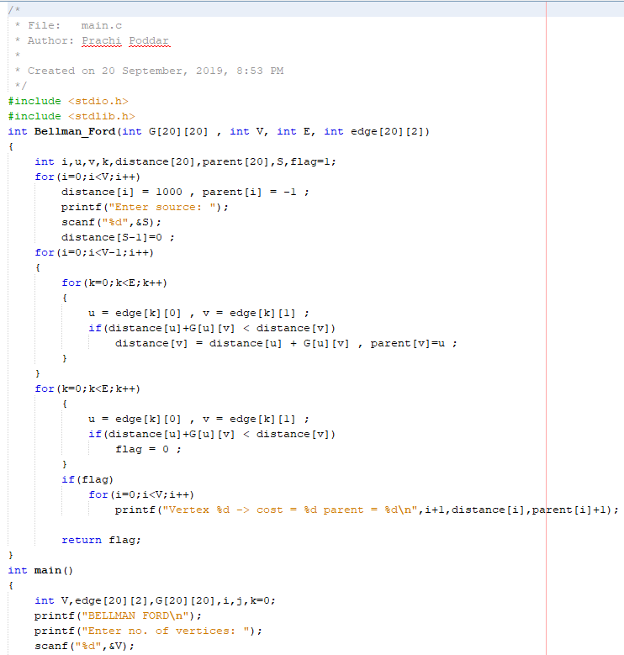

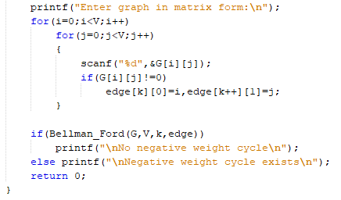

1. Results

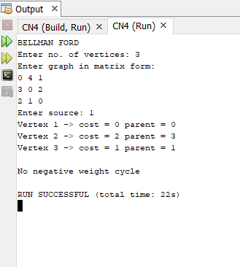

1. Analysis and Discussions

Bellman Ford's algorithm is used to find the shortest paths from the source vertex to all other vertices in a weighted graph. It depends on the following concept: Shortest path contains at most n−1 edges, because the shortest path couldn't have a cycle. This algorithm works by overestimating the length of the path from the starting vertex to all other vertices. Then it iteratively relaxes those estimates by finding new paths that are shorter than the previously overestimated paths. It goes through each edge in every iteration. If there are N vertices then we will iterate N - 1 times to get the shortest distance and we do the Nth iteration to check if there is any negative cycle.

1. Conclusions

The implementation has been done and the program runs successfully.

1. Comments
2. Limitations of the experiment

It is slower to converge than Link State. It is at risk from the count-to-infinity problem. It creates more traffic than Link State since a hop count change must be propagated to all routers and processed on each router.

1. Limitations of the results obtained

Routers must recalculate their routing tables before forwarding changes

Susceptible to routing loops (count-to-infinity)

Bandwidth requirements can be too great for WAN or complex LAN environment.

1. Learning

Learnt about distance vector routing, its use, its implementation and also creating a routing table using distance vector routing.

1. Recommendation:

None.